Project Design Phase-II
Data Flow Diagram & User Stories

Date | 31 January 2025
Team ID | LTVIP2026TMIDS41308
Project Name | Online Payment Fraud Detection With Machine Learning
Maximum Marks | 4 Marks

Data Flow Diagrams:
A Data Flow Diagram (DFD) is a traditional visual representation of the information flows within a system. A neat and clear DFD can depict the right amount of the system requirement graphically. It shows how data enters and leaves the system, what changes the information, and where data is stored.
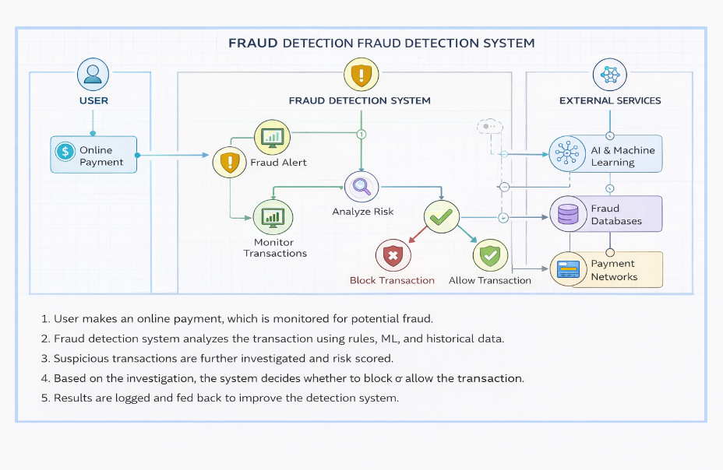
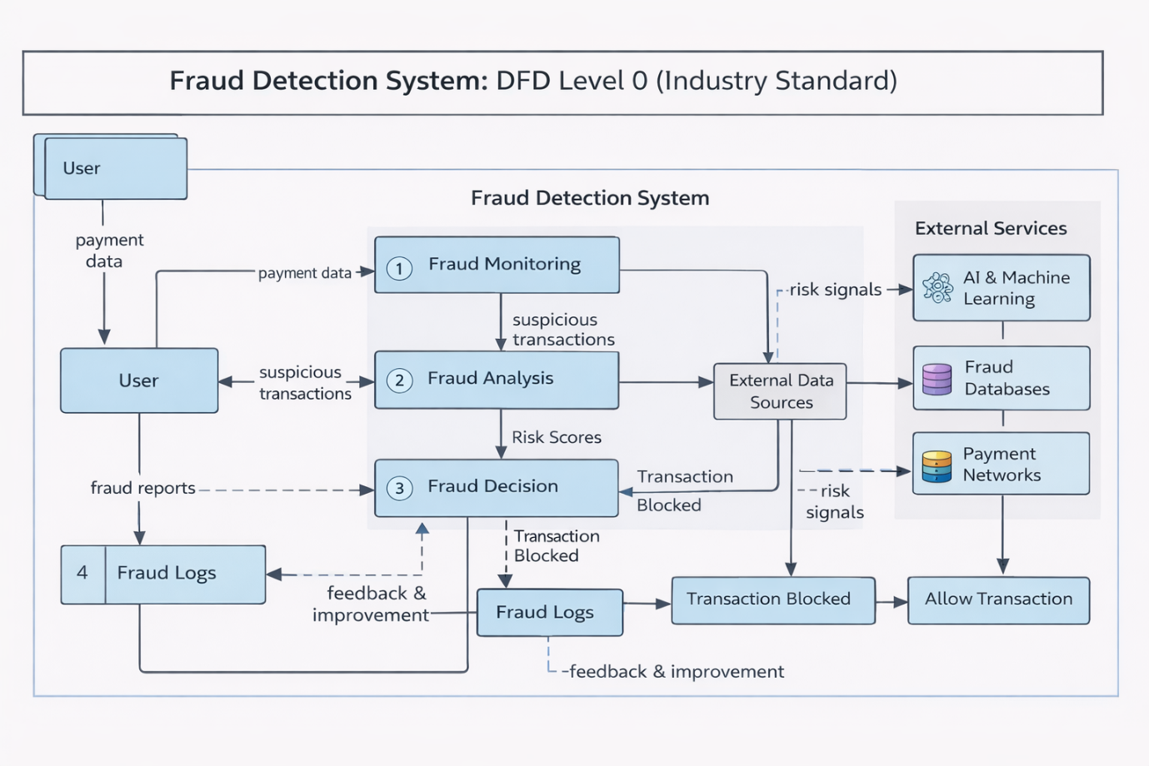

User Stories
Use the below template to list all the user stories for the product
User Type | Functional Requirement (Epic) | User Story Number | User Story / Task | Acceptance criteria | Priority | Release
Customer (Mobile user) | Registration | USN-1 | As a user, I can register for the application by entering my name, email, password, and confirming my password. | I can access my account / dashboard | High | Sprint-1
 |  | USN-2 | As a user, I will receive confirmation email once I have registered for the application | I can receive confirmation email & click confirm | High | Sprint-1
 |  | USN-3 | As a user, I can register for the application through OTP verification. | I can verify my mobile number & access dashboard | Medium | Sprint-1
 | Login | USN-4 |  | I can login successfully & access dashboard | High | Sprint-1
  As a user, I can log into the application by entering email & password.
 |  | USN-5 | As a user, I can reset my password if I forget it. | I can receive reset link & set new password | High | Sprint-1
 |  | USN-6 | As a user, I can make an online payment securely. | Transaction is processed successfully | High | Sprint-1
  Payment Transaction
 |  | USN-7 | As a user, I get notified if my transaction is flagged as suspicious. | I receive alert notification for suspicious activity. | High | Sprint-2
 | Dashboard | USN-8 | As a user, I can view my transaction history. | I can see all past transactions with status | Medium | Sprint-2
Customer (Web user) | Payment Monitoring | USN-9 | As a web user, I can view fraud risk score of my transactions. | Fraud score is displayed for each transaction | High | Sprint-2
Customer Care Executive | Fraud Review | USN-10 | As a customer care executive, I can review flagged transactions. | I can see list of flagged transactions | High | Sprint-2
 |  | USN-11 | As a customer care executive, I can mark a transaction as fraud or genuine. | Transaction status updates successfully | High | Sprint-2
Administrator | Fraud Detection Model | USN-12 |  | Dataset uploads successfully | High | Sprint-1
  As an admin, I can upload transaction datasets to train the fraud detection model.
 |  | USN-13 | As an admin, I can configure fraud detection threshold. | Threshold updates successfully | High | Sprint-2
 | Reports | USN-14 | As an admin, I can generate fraud detection reports. | Fraud report is generated successfully | Medium | Sprint-3
 | Monitoring | USN-15 | As an admin, I can monitor real-time fraud alerts. | Real-time alerts are displayed on dashboard | High | Sprint-2

